TEST PLAN FOR
REAL TIME CHAT APP

Version | Change Date | By | Description
version number | Date of Change | Name of person who made changes | Description of the changes made
001 | 30.10.23 | Sachin Verma | Intial draft

1 Introduction 2
1.1 Scope 2
1.1.1 In Scope
1.1.2 Out of Scope
1.2 Quality Objective 3
1.3 Roles and Responsibilities 3
2 Test Methodology 4
2.1 Overview 4
2.2 Test Levels 4
2.3 Bug Triage
2.4 Suspension Criteria and Resumption Requirements
2.5 Test Completeness 6
3 Test Deliverables 6
4 Resource & Environment Needs 9
4.1 Testing Tools 9
4.2 Test Environment 9
5 Terms/Acronyms 10

Introduction
As the time going on, the development of information and communication technology is growing so faster and playing very important role in the society. As with the help of the information and communication technologies we can facilitate the people to receive the information and communicate with each other from anywhere, anytime and faster than before. If we see the today’s scenario after the technology have been arrived most of the people don’t use newspaper for getting the information and even not much uses the news channel now a days for getting information, Majority is using the smart technology for receiving any type of information with the help of smart phones or other devices and if we talk about the chat application, in the chat application everyone is sharing many news there itself only about what’s going on around them or in any place in the world, as with the help of the chat application information is spreading so faster than before. Currently, the chat application has been developed by many developers and it has its own advantages and disadvantages as every other thing have, and it’s giving us more options to decide which thing is better for us and what features are really required in the application and what not, as the review of the users using the application tells a lot about the application and their experience towards the application. The Chat application is fully responsive as it means totally user friendly for every web-based or mobile or any other device users. It is built using Node.js, Socket.io, MongoDB, Passport.js, Auth2.0 and other JavaScript libraries.

Scope
Functional requirement

User Registration and Authentication:

Users should be able to create accounts.
Users must authenticate their identities securely.

User Profiles:
Users can set up profiles with information like names, profile pictures, and status messages.

Contact Management:
Users can add and manage contacts.
Users can create and manage groups for group chats.

Real-Time Messaging:
Users can send and receive text messages in real-time.
Messages should be delivered promptly and reliably.

Non functional requirement

Performance:
Responsiveness: The application should respond to user actions quickly, with minimal latency.
Scalability: The chat application should be able to handle a growing number of users and messages without significant performance degradation.

Security:
Data Encryption: Messages and user data must be encrypted in transit and at rest.
Authentication and Authorization: Secure user authentication and authorization mechanisms should be in place.

Reliability:
High Availability: The chat application should be available and accessible to users with minimal downtime.

Scalability:
The system should be designed to scale horizontally and vertically to accommodate increased user loads.

Quality Objective

Here make a mention of the overall objevtie that you plan to achive without
your testing

Some objectives of your testing project could be

- Ensure the Application Under Test conforms to functional and non-functional requirements
- Ensure the AUT meets the quality specifications defined by the client
- Bugs/issues are identified and fixed before go live

Roles and Responsibilities
Detail description of the Roles and responsibilities of different team members like
- QA Analyst-sachin kushwaha
- Test Manager-Dr.ajay kumar shrivastav
- Configuration Manager- Mr.abhishek goyal
- Developers- sachin kushwaha,sachin verma,sidhartha
- Installation Team sachin kushwaha,sachin verma,sidhartha

Test Methodology

Overview

real-time chat application involves stages such as requirement analysis, test planning, environment setup, and test case design. Functional and non-functional testing is performed, including cross-platform, load and performance, security, usability, and regression testing. Compatibility and localization tests ensure broad user coverage. Automated testing tools are used for efficiency. Documentation and reporting are critical for tracking issues. User acceptance testing and feedback are essential for end-user satisfaction. The final release testing and post-release monitoring ensure application readiness and ongoing quality. This comprehensive methodology ensures a reliable, secure, and user-friendly chat application.

Test Levels

Unit Testing:
Scope: Individual components and functions of the neural style transfer algorithm.
Objective: To verify that each component works as intended, including layers, loss functions, and optimization steps.
Testing Approach: Developers and machine learning engineers conduct unit tests to validate the correctness of the algorithm at a granular level.

Integration Testing:
Scope: The interactions and interfaces between various components, libraries, and frameworks used in the project.
Objective: To ensure that the integration of different components does not introduce errors or inconsistencies in the style transfer process.
Testing Approach: Developers and testers assess the data flow and interactions between components and detect any integration issues.

Functional Testing:
Scope: The complete neural style transfer system.
Objective: To validate that the system functions according to specified requirements and that it performs accurate style transfers.
Testing Approach: Testers execute functional tests by providing input images and verifying that the output images meet the desired content and style transfer criteria.

Performance Testing:
Scope: Assessing the system's speed and efficiency in handling style transfer tasks.
Objective: To measure how well the system performs in terms of processing time, memory utilization, and resource consumption.
Testing Approach: Performance tests evaluate the system's response time and resource usage under various loads and conditions.

Usability Testing:
Scope: The user interface and user experience.
Objective: To assess how user-friendly and intuitive the interface is for users uploading content and style images.
Testing Approach: Usability tests involve users interacting with the system to evaluate the ease of use, clarity, and navigation of the interface.

Security Testing:
Scope: The system's security mechanisms, especially for handling user data.
Objective: To identify and mitigate potential security vulnerabilities, including data breaches and unauthorized access.
Testing Approach: Security testing includes penetration testing, data encryption checks, and access control assessments.

Compatibility Testing:
Scope: The system's compatibility with various platforms and devices.
Objective: To ensure that the system functions correctly on different browsers, operating systems, and devices.
Testing Approach: Testers verify that the system is compatible with a range of devices and configurations.

Regression Testing:
Scope: The entire system after updates or changes.
Objective: To confirm that new changes or enhancements do not introduce defects or negatively impact existing functionality.
Testing Approach: Automated regression tests are executed to validate that previously tested features still work as expected.

Test Completeness
Here you define the criterias that will deem your testing complete.
For instance, a few criteria to check Test Completeness would be
- 100% test coverage
- All Manual & Automated Test cases executed
- All open bugs are fixed or will be fixed in next release

Test Deliverables

Test cases :
Test Case | Test Objective | Test Data | Expected Result | Actual Result | Pass/Fail
1 | User Login | User Id and Password | Only Valid User login in the system | Unauthorized  User can  not login | Pass
2 | User registration | Email,  Passward,  Confirm Passward | Valid Email,  Passward must be same  as confirm Passward  ,Registered | Registration  Sucessfull | Pass

3 | To confirm that users can send text messages in real-time. | Two users logged into the chat application.  A text message to be sent. | The message should be sent from one user to another and displayed in real-time. | The message is sent and received in real-time. | Pass
4 | Group Chat Creation | A list of users to be invited to the group chat. | The user should be able to create a group chat and invite other users | The user successfully creates a group chat | Pass
5 | Typing Indicators | Two users in a chat.  One user begins typing a message | The recipient should receive a typing indicator when the sender starts composing a message. | The recipient receives a typing indicator when the sender starts typing. | Pass
6 | To ensure that users receive messages sent while they were offline upon logging in. | Messages sent by others while the user was offline. | The user should receive the messages sent while they were offline when they log in. | The user receives the offline messages upon logging in. | Pass
7 | To ensure that users can export their chat history. | Try to export chat history. | The user should be able to export their chat history, | The user successfully exports their chat history | Pass
8 | To ensure that users can search  Other user | Search user name | Able to Search user name | User Sucessfully Searched | Pass

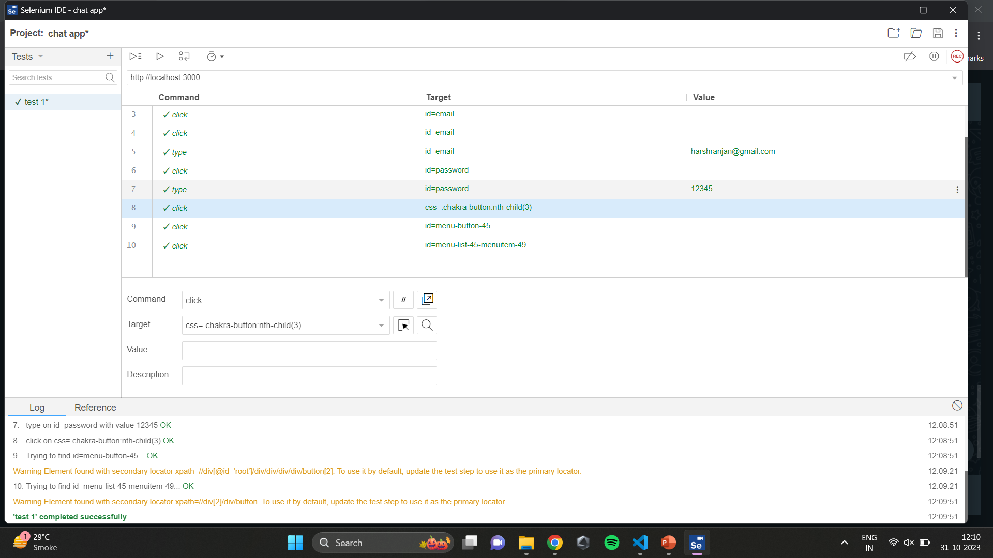

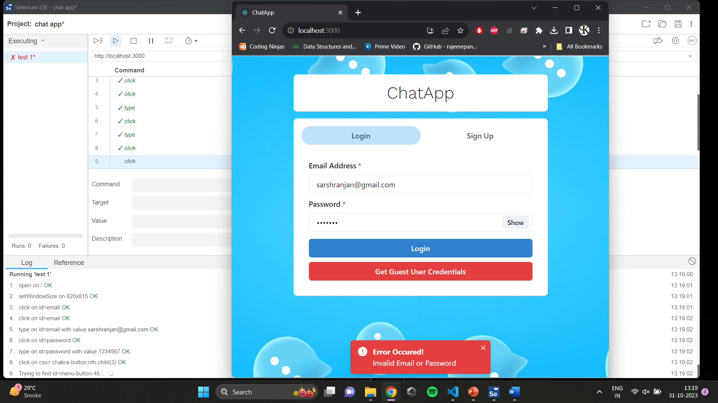

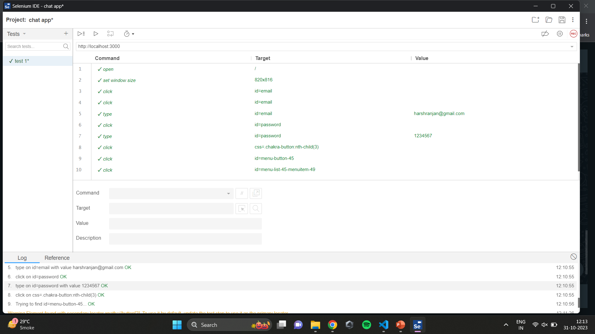

Resource & Environment Needs

Testing Tools

Make a list of Tools like
- Requirements Tracking Tool
- Bug Tracking Tool
- Automation Tools
Required to test the project

Test Environment
It mentions the minimum hardware requirements that will be used to test the Application.

Following software’s are required in addition to client-specific software.

- Windows 8 and above
- Office 2013 and above
- MS Exchange, etc.

Terms/Acronyms
Make a mention of any terms or acronyms used in the project

TERM/ACRONYM | DEFINITION
API | Application Program Interface
AUT | Application Under Test

Dr. Ajay Kumar srivastava Mr. Abhishek Goyal
(Project Guide) (Testing Lab Faculty)

Submitted By Submitted To:
Sachin Kushwaha (2000290120130) – 7B Prof. Neha Shukla
Sachin Verma(2000290120131) – 7B Project Coordinator
Sidharth Kushwaha(2100290129009) – 7B Dept. of Computer Science

